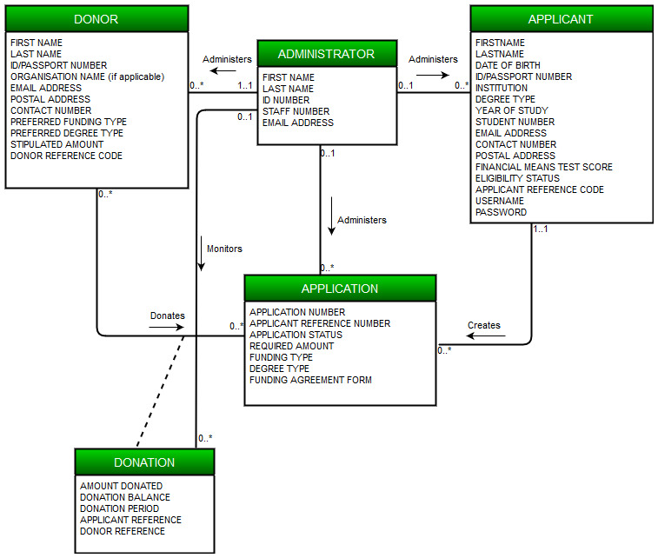4. Revised Class Diagram for the #fundMe system

The following is a class diagram which serves as a representation of the structure of the system’s database. It also shows the relationships among the tables of the database, the relationships of which we elicited from the given business rules. In this case, the tables are Applicant, Application, Donor, Donation and Administrator, as can be seen in the diagram on the left.

5. Revised Use case set for the #fundMe system

The following table is an illustration of a use case set. Which essentially serves as a framework of the events that are expected to take place within the #fundMe system, where Applicant, Application, Donor, Donation and Administrator are the tables within the system’s database, as seen in the Class Diagram above. The Create, Read and Update are the core operations that are to trigger the attention of the system.

|  |  |  |  |
| --- | --- | --- | --- |
|  | Use Case | Description | Used use cases |
| APPLICANT | | | |
|  | Create Applicant | Registration is required for first time applicants. |  |
| Read Applicant | Allows applicant to view applicant details. |  |
| Update Applicant | Allows applicant to update applicant details. | Read applicant |
| APPLICATION | | | |
|  | Create Application | Allows user to apply for required funding. |  |
| Read Application | Allows user to view application from the database. |  |
| Update Application | Allows user to update application details. | Read application |
| DONOR | | | |
|  | Create Donor | Each new donor must be created by an administrator. |  |
| Read Donor | Allows admin to view a donor’s details. |  |
| Update Donor | Allows admin to update a donor’s details. | Read Donor |
| DONATION | | | |
|  | Create Donation | A new donation is created when a match has been made between applicant and donor. |  |
| Read Donation | Allows user to view donation details. |  |
| Update Donation | Allows user to update donation details. | Read Donation |
| ADMINISTATOR | | | |
|  | Create Administrator | Creates new administrator. |  |
| Read Administrator | Reads administrator’s details. |  |
| Update Administrator | Updates administrator’s details. | Read Administrator |
| REPORT | | | |
|  | Generate report | | |

6. Revised Use Case Diagram for #fundMe system

The use case diagram illustrates the interaction of the users of the system, Applicant and Administrator, with the system, as well as which operation, according to the use case set above, concerns which users. In this particular case both the Applicant and the Administrator are primary actors of the system.

The donor plays no role in the system and thus they do not appear as an actor of the system in the diagram.

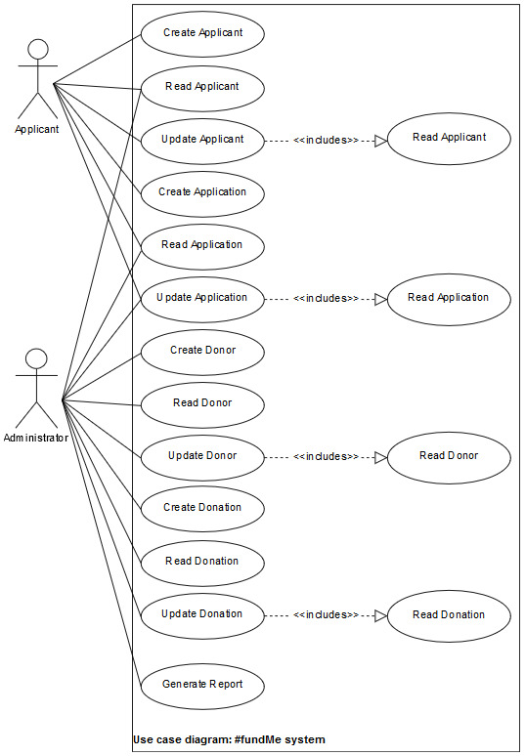

7.1.1 Fully-dressed use case description for Update

Applicant

The fully-dressed use case description below gives a more detailed elucidation of the Update Applicant use case/process. It sheds light upon the steps necessary to perform the process successfully and exceptions/alternatives in the case of a deviation from the main path, as well as what must be true before and after the process takes place.

|  |  |  |
| --- | --- | --- |
| **Use case name:** | Update Applicant | |
| **Scope:** | #fundMe System | |
| **Triggering Event:** | Applicant requests to update applicant | |
| **Brief Description:** | When an Applicant wishes to update their demographic data, they can request to update applicant. The system will enable the applicant to make changes to applicant. The Applicant then makes the desired changes and saves those changes. The system then makes record of these changes and captures them into the APPLICANT data structure. After which it displays the updated version of the demographic data. The system then sends a confirmation message to the Applicant, pertaining to the changes made. | |
| **Actor(s):** | Applicant(Primary) | |
| **Related use case(s):** | Read Applicant | |
| **Stakeholder and interests:** | Applicant: Desires to update their details efficiently and with ease.  Administrator: Desires to always have up-to-date information about the applicant to avoid providing inaccurate information to donors and generating reports based off out-dated data.  The Organisation: Desires to be provided with accurate and up-to-date reports and information for decision making with regards to the impact of #fundMe. | |
| **Pre-conditions:** | The applicant’s record must already exists within the APPLICANT table in the #fundMe database. | |
| **Post-conditions:** | Updated demographic data are recorded into the APPLICANT table.  Generated confirmation message detailing the updates made to the Applicant’s demographic data.  Confirmation message detailing the updates made to the Applicant’s demographic data is sent to the Applicant. | |
| **Flow of activities:** | Actor | System |
| 1. Applicant requests to update applicant 2. Applicant enters applicant reference number 3. Applicant updates demographic data 4. Applicant saves updates   5.Appilcant closes update  applicant | * 1. Prompts for applicant   reference number   * 1. Verifies applicant reference number   2. Uses applicant reference number to search for Applicant’s record in the database   3. Invokes the Read Applicant use case   4. Displays Applicant’s demographic data   5. Records updates   6. Stores updates in APPLICANT table   7. Displays updated demographic data   8. Sends a confirmation message to the Applicant, pertaining to the updates made. |
| **Extensions:** | 1. Applicant enters   incorrect applicant reference number | A.1 Verifies applicant  reference number  A.2 Displays error message  A.3 Returns to step 1.1 of the  flow of activities |

7.1.2 Use case diagram for Update Applicant

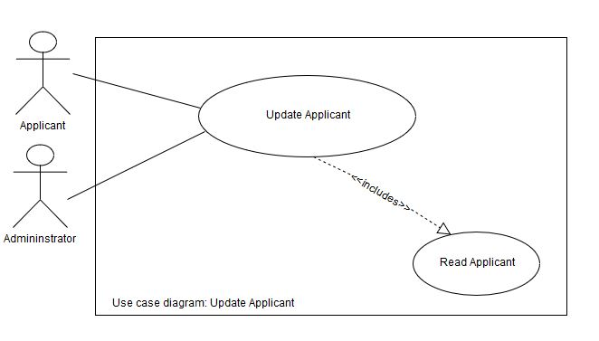The following use case diagram is a representation of the interaction between the process of update applicant and the applicant. It also shows the related process, read applicant, which is necessary for update applicant to take place.

7.1.3 Sequence Diagram for Update Applicant

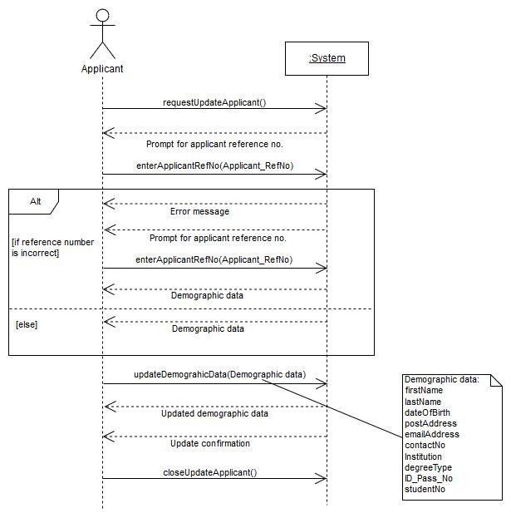The following sequence diagram represents the order in which communication takes place between the applicant and the system during the update applicant process.